University of Science and Technology
- Wrocław-



LABORATORY 3: UTILIZING SOFTWARE FOR REQUIREMENTS MANAGEMENT

SUPPORT FOR IT PROJECT MANAGEMENT
2025/2026
Teacher: Piotr Zabawa
Student: Álvaro Puebla Ruisánchez 293867

Table of Contents
Table of Contents 2
1. Software Overview 3
1.1 Name and Purpose 3
1.2 Key Functionality 3
1.3 Why Jira Software Was Selected 4
2. Performed Tasks 5
2.1 Task 1 - Create 3 User Stories for a "Library App" 5
2.2 Task 2 - Assign a MoSCoW Label to Each Story 6
2.3 Task 3 - Move one story from "To Do" to "In Progress" 7
3. Summary 8
3.1 Software Suitability Assessment 8
3.2 Evaluation of Software Functionality 8
3.3 User Interface Evaluation 8
3.4 Evaluation of Other Software Attributes 9

1. Software Overview

1.1 Name and Purpose
The software selected for this laboratory session is Jira Software, a web-based project and requirements management application developed by Atlassian. Jira Software is designed to support teams in planning, tracking, and managing software development projects. Its primary purpose in the context of this course is to serve as a centralized platform for requirements management - enabling project managers, developers, and stakeholders to define, prioritize, trace, and monitor project requirements throughout the entire development lifecycle.
In IT Project Management, effective requirements management is a critical success factor. Projects frequently fail due to scope creep, miscommunication between teams, and loss of information across fragmented communication channels. Jira Software directly addresses these issues by providing a single, authoritative source of truth for all project demands, thereby ensuring that the entire team operates from a consistent and up-to-date set of requirements.

1.2 Key Functionality
Jira Software provides a broad set of functionalities aligned with the core needs of requirements management. The following capabilities were identified as particularly relevant during the laboratory session:
Requirements Backlog: Jira allows the creation and management of a prioritized backlog composed of user stories, tasks, and descriptions with associated tags. This centralizes all project needs and prevents information loss by ensuring that requirements are never scattered across emails or informal communications.
Traceability Matrix: The tool supports the linking of requirement identifiers to corresponding tasks and test IDs, producing a structured overview that demonstrates whether every stated requirement has been implemented and verified. This is essential for audit trails and project accountability.
Workflow Management: Jira's Kanban and Scrum boards provide visual representations of task progress using status columns such as "To Do," "In Progress," and "Done." This enables real-time tracking of each requirement as it moves through the development pipeline.
Version History: Every change made to a requirement - including modifications to its text, status, or assignee - is logged with a timestamp and the identity of the user who made the change. This chronological audit log is critical for controlling scope creep and resolving disputes caused by misunderstandings.
Stakeholder Collaboration: Jira facilitates communication directly within the tool through comments, @mentions, and file attachments on individual issues, supported by email notifications. This reduces reliance on external communication tools and keeps all relevant discussions tied to the specific requirement in question.
Reporting and Exporting: The platform offers reporting features that aggregate project status data, which can be filtered by date and exported to common formats (PDF or Excel) for stakeholder presentations or formal reporting purposes.

1.3 Why Jira Software Was Selected
Jira Software was selected for this laboratory for several well-founded reasons. First, it is widely recognized as the industry standard for IT project and requirements management, making hands-on experience with the tool directly relevant to professional practice. Second, Jira offers native support for Agile methodologies - including Scrum and Kanban - and integrates seamlessly with the MoSCoW prioritization method, which was a core concept introduced in this laboratory session. Third, its free tier accommodates up to ten users, making it accessible for academic purposes without financial barriers. The combination of professional-grade functionality and zero-cost accessibility makes Jira Software the most appropriate choice for both learning objectives and practical requirements management tasks.

2. Performed Tasks

2.1 Task 1 - Create 3 User Stories for a "Library App"
Task description:
The first task consisted of creating three user stories within a newly created Jira Kanban project named "Lab_Requirements". A user story is a short, informal description of a software feature written from the perspective of the end user, typically following the format: "As a [type of user], I want [some goal], so that [some reason]." User stories form the foundation of the requirements backlog and represent the functional expectations of the client.
The following three user stories were created for the Library App:
- US-01 - Book Search: "As a library member, I want to search for books by title, author, or ISBN, so that I can quickly find the materials I need."
- US-02 - Loan Management: "As a library member, I want to borrow and return books through the system, so that I can manage my loans without visiting the front desk."
- US-03 - Overdue Notifications: "As a librarian, I want the system to automatically send overdue notifications to members, so that I can reduce manual administrative work."
Each story was entered as a separate issue in the Jira backlog, assigned a unique identifier, and given a short summary title along with a description elaborating on its purpose and acceptance criteria.

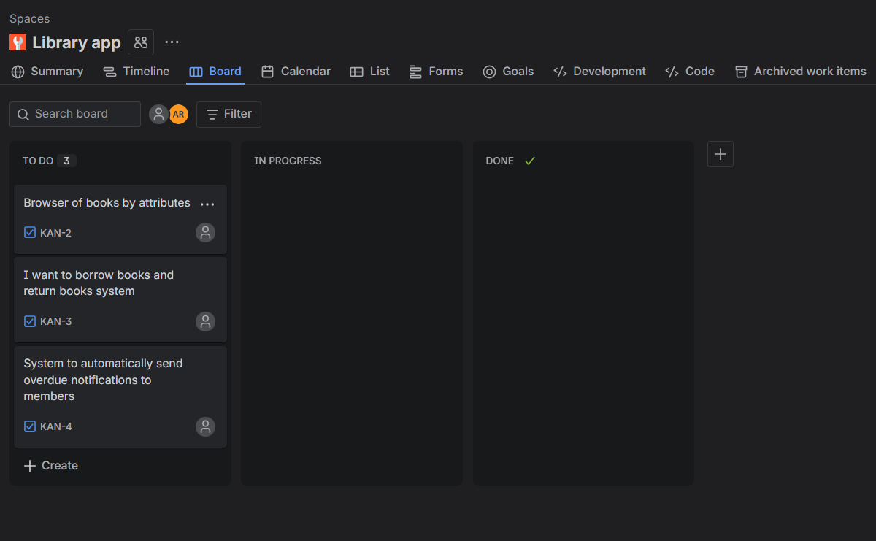
Figure 1. Screenshot of the Jira backlog displaying the three created user stories (US-01, US-02, US-03) for the Library App project.

2.2 Task 2 - Assign a MoSCoW Label to Each Story
Task description:
The second task involved applying the MoSCoW prioritization framework to each of the three user stories created in Task 1. MoSCoW is a widely used requirements prioritization technique that classifies each requirement into one of four categories:
- Must Have - Critical for delivery; the project cannot be considered complete without it.
- Should Have - Important but not vital; its absence would be noticed but would not cause project failure.
- Could Have - Desirable extras that enhance the product but can be deferred without significant impact.
- Won't Have - Explicitly out of scope for the current iteration.
In Jira, MoSCoW labels were applied using the Priority field or custom Labels on each issue. The assignments made were as follows:
User Story | Title | MoSCoW Priority
US-01 | Book Search | Must Have
US-02 | Loan Management | Must Have
US-03 | Overdue Notifications | Should Have
Book Search and Loan Management were classified as Must Have because they represent core functional requirements without which the Library App would be unable to fulfil its primary purpose. Overdue Notifications were classified as Should Have because, while highly valuable for operational efficiency, their absence would not prevent the system from functioning.
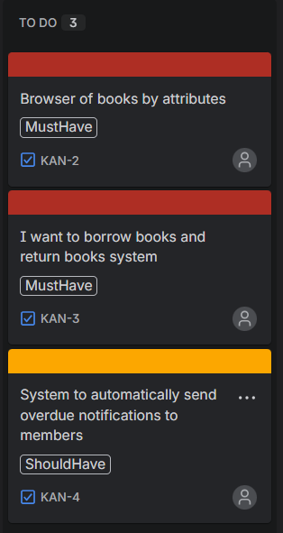
Figure 2. Screenshot of the Jira issue list showing each user story with its assigned MoSCoW priority label.

2.3 Task 3 - Move one story from "To Do" to "In Progress"
Task description:
The third task demonstrated the use of Jira's workflow management capabilities by transitioning one of the user stories from the "To Do" column to the "In Progress" column on the Kanban board. This action simulates the real-world scenario in which a development team begins actively working on a requirement, reflecting a change in its status within the project lifecycle.
User story US-01 (Book Search) was selected for this transition, as it represents the highest-priority functional requirement. The transition was performed directly on the Kanban board by dragging the card from the "To Do" column to the "In Progress" column. Upon doing so, Jira automatically updated the issue status and recorded the status change in the issue's version history, including the timestamp and the user account that performed the action.
This step illustrates how Jira's real-time workflow tracking ensures that the entire project team can immediately observe changes in the status of any requirement, maintaining transparency and enabling effective coordination.
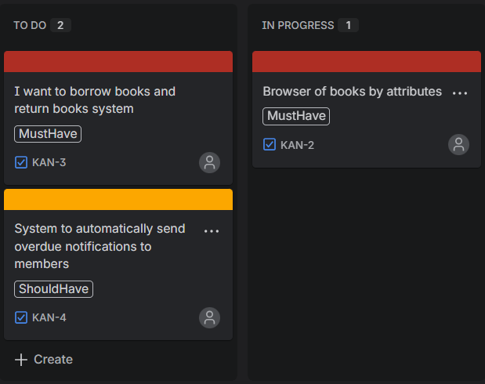
Figure 3. Screenshot of the Jira Kanban board showing US-01 (Book Search) moved to the "In Progress" column, with US-02 and US-03 remaining in "To Do."

3. Summary

3.1 Software Suitability Assessment
Jira Software proves to be highly suitable for requirements management tasks within the context of IT project management. It directly addresses the key challenges identified at the outset of this laboratory - namely, scope creep, miscommunication, and information fragmentation - by providing a centralized, traceable, and collaborative environment for managing all project requirements. The tool's support for Agile frameworks and the MoSCoW prioritization method makes it particularly well-aligned with the methodological approach taught in this course. Its backlog management, workflow visualization, and issue-linking features collectively satisfy all four core user needs identified in the course materials: centralization, traceability, collaboration, and history tracking. For a team of any size operating in an IT project context, Jira Software represents a robust and professionally validated choice.

3.2 Evaluation of Software Functionality
The functional scope of Jira Software is comprehensive and well-structured. The requirements backlog provides a reliable mechanism for capturing and organizing all project demands in a single location. The Kanban board's visual representation of workflow statuses facilitates progress monitoring without the need for separate status reporting meetings. The version history feature, which logs every change with user attribution and timestamps, is particularly valuable for maintaining accountability and preventing uncontrolled scope changes. The issue-linking mechanism, which supports the construction of a traceability matrix, ensures that requirements can be mapped directly to their corresponding development tasks and test cases — a capability that is essential for formal project audits. The only notable limitation in functionality is that some of the more advanced reporting and roadmap features are restricted to paid tiers, which may limit the depth of analysis available in a free academic environment.

3.3 User Interface Evaluation
Jira Software's user interface is clean, professional, and logically organized. Navigation between the backlog, Kanban board, and individual issues is intuitive, and the drag-and-drop interaction for managing workflow transitions requires no prior training to perform correctly. The issue creation form is straightforward, offering clearly labeled fields for summaries, descriptions, priorities, labels, and assignees. The Kanban board provides an at-a-glance view of project status that is easily understood by both technical team members and non-technical stakeholders. However, for users who are entirely new to project management software, the breadth of available options and configurations within Jira can initially appear overwhelming. The abundance of menus, settings panels, and project configuration options may require a short onboarding period before users can navigate the platform with full confidence.

3.4 Evaluation of Other Software Attributes
Performance: Jira Software performs reliably as a cloud-hosted web application, with fast page load times and responsive interactions during normal usage. No significant performance issues were encountered during the laboratory session.
Accessibility: The platform is accessible from any modern web browser without the need to install local software, which simplifies deployment in academic and professional environments alike. The interface is responsive and can be used on both desktop and mobile devices, extending accessibility for team members who need to update requirements or check project status while on the move.
Scalability: While the free tier is suitable for small teams (up to ten users), Jira scales effectively to enterprise-level deployments, supporting thousands of users across multiple projects. This makes any skills acquired during this laboratory directly transferable to real-world professional environments.
Limitations: The primary limitations of the free tier in this context include restricted access to advanced reporting dashboards, the absence of multi-project roadmaps, and limits on automation rules. Additionally, integration with external tools such as Confluence (for documentation) or Bitbucket (for version control) requires either a paid plan or manual configuration. These constraints are acceptable for a laboratory context but would need to be considered in a production project environment.
Overall, Jira Software demonstrates a strong combination of professional-grade functionality, practical usability, and cost-effective accessibility, making it an excellent tool for both academic study and real-world IT project requirements management.

